Create 2 EC2 instances on 2 different regions and install nginx using terraform script.

TASK 2
Create Project Folder
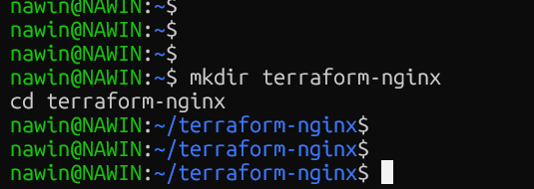

Initiate the script

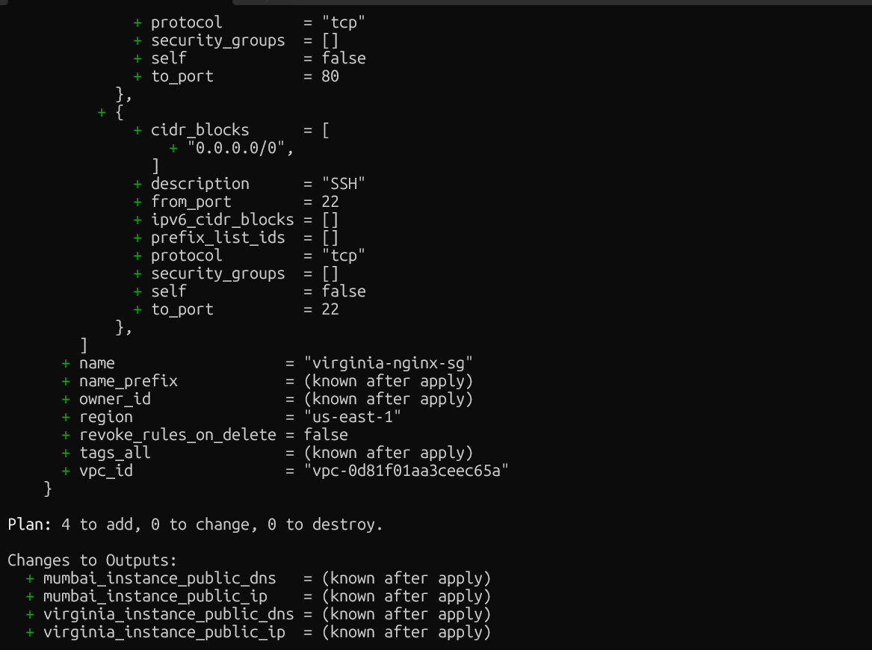

Terraform apply

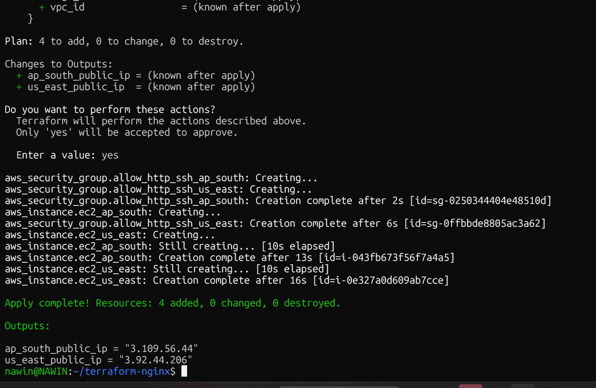

EC2 Status

